

CSA0501-DATABASE MANAGEMENT SYSTEMS

LAB EXPERIMENTS

EXPERIMENT 1 -- DDL Commands (CREATE, ALTER, DROP, TRUNCATE, RENAME)

AIM:
To study and implement SQL Data Definition Language (DDL) commands such as CREATE, ALTER, DROP, TRUNCATE, and RENAME by creating and modifying the INTERN_EMP_INFO table

PROCEDURE:
- Open the SQL environment (MySQL Workbench, Oracle SQL Developer, phpMyAdmin, etc.).
- Create the INTERN_EMP_INFO table using the CREATE TABLE command.
- Use the ALTER TABLE command to add, modify, or remove columns and constraints.
- Rename the table using the RENAME command.
- Delete all records from the table using the TRUNCATE command while keeping the table structure intact.
- Remove the entire table from the database using the DROP TABLE command.
- Verify the changes after each command by using DESCRIBE, SHOW TABLES, or SELECT statements where applicable.
- Record the output and observations for each command.

PROGRAM:

1. CREATE DATABASE
CREATE DATABASE INTERN_EMPLOYEE;
USE INTERN_EMPLOYEE;

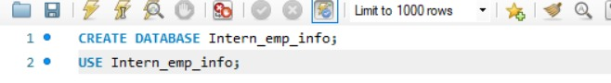

2. CREATE TABLE
CREATE TABLE INTERN_EMP_INFO
(
EmpID INT,
EmpName VARCHAR(50),
EmpDept VARCHAR(30),
EmpSalary DECIMAL(10,2),
Performance VARCHAR(20),
EmpPhone BIGINT
);
DESC INTERN_EMP_INFO; 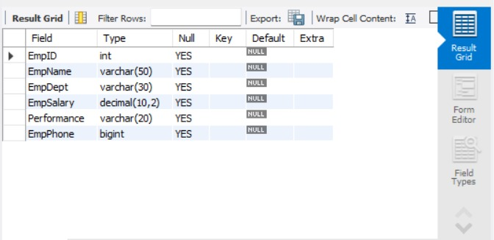
3. ALTER – ADD COLUMN:
Add a new column called Email.
ALTER TABLE INTERN_EMP_INFO ADD Email VARCHAR(50);
DESC INTERN_EMP_INFO;
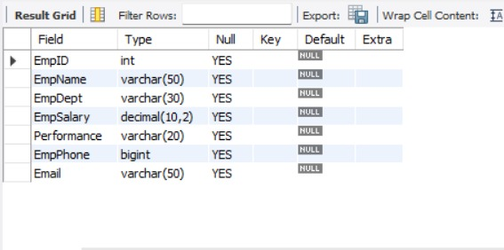
4. ALTER – MODIFY COLUMN:
Increase the size of EmpName.
ALTER TABLE INTERN_EMP_INFO
MODIFY EmpName VARCHAR(100);
DESC INTERN_EMP_INFO;
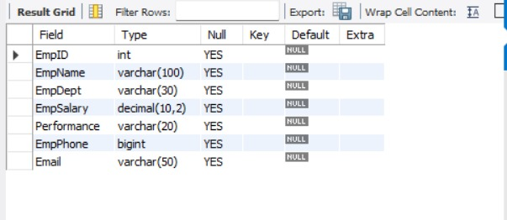

5. ALTER – DROP COLUMN:
Remove the Email column.

ALTER TABLE INTERN_EMP_INFO

DROP COLUMN Email;

DESC INTERN_EMP_INFO;
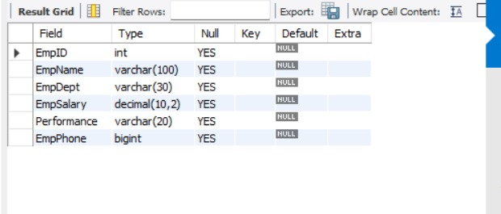
6. RENAME TABLE:
Rename INTERN_EMP_INFO to EMPLOYEE_DETAILS

RENAME TABLE INTERN_EMP_INFO
TO EMPLOYEE_DETAILS;

SHOW TABLES;

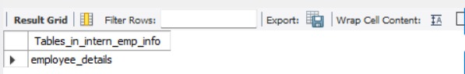
7. INSERT SAMPLE DATA:
INSERT INTO EMPLOYEE_DETAILS
VALUES
(101,'Rahul','IT',25000.00,'Excellent',9876543210),
(102,'Priya','HR',22000.00,'Good',9876501234);

SELECT * FROM EMPLOYEE_DETAILS;
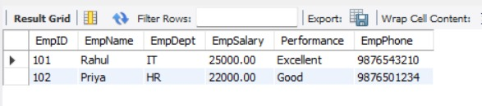
8. TRUNCATE TABLE:
TRUNCATE TABLE EMPLOYEE_DETAILS;

SELECT * FROM EMPLOYEE_DETAILS;
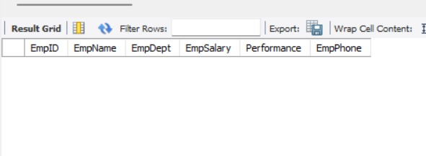
9. DROP TABLE:
DROP TABLE EMPLOYEE_DETAILS;
SHOW TABLES;
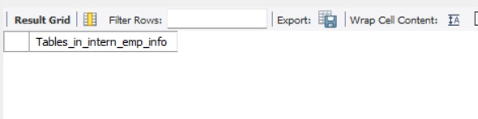
RESULT:
Thus, the DDL commands CREATE, ALTER, RENAME, TRUNCATE, and DROP were executed successfully.

